Managed Availability Troubleshooting Beginners Guide

- Open Powershell as an Admin

- This can be run from an Exchange server and it will list out all recover actions taken by MA for that server.
  - $RecoveryActionResultsEvents = Get-WinEvent –ComputerName <Server>-LogName Microsoft-Exchange-ManagedAvailability/RecoveryActionResults
  - $RecoveryActionResultsXML = ($RecoveryActionResultsEvents | Foreach-object -Process {[XML]$_.toXml()}).event.userData.eventXml | Select EndTime, ID, State, ResourceName, RequestorName,Result| Out-GridView

- Output will be similar to below. Take note of the RequestorName of the ID (what happened or is happening to the server)

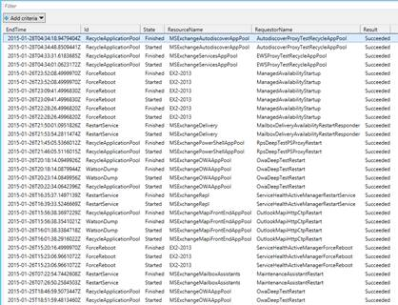

- Now we find the Monitor that triggered the action. Run the below:

  - $DefinedResponders = (Get-WinEvent –ComputerName <Server> -LogName Microsoft-Exchange-ActiveMonitoring/ResponderDefinition | % {[xml]$_.toXml()}).event.userData.eventXml
  - $DefinedResponders | ? {$_.Name –eq "TheRequestorNameFromAbove"} | select TypeName,Name,TargetResource,AlertMask,WaitIntervalSeconds | Out-GridView
It Should look something like this take note of the AlertMask (monitor that triggered the responder)
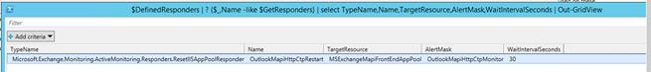
- Now we can find out which probe(s) that feed data to that monitor.
  - $DefinedMonitors = (Get-WinEvent –ComputerName <Server> -LogName Microsoft-Exchange-ActiveMonitoring/MonitorDefinition | % {[xml]$_.toXml()}).event.userData.eventXml
  - ($DefinedMonitors | ? {$_.Name -eq ‘ServiceHealthMSExchangeReplEndpointMonitor’}).SampleMask

- You can now use that Probe as your investigation point.

